**Text-to-Speech while in Moodle Lock Down Browser**

Mac

The Mac version of LockDown Browser works with VoiceOver (the standard screen reader that comes with the Mac OS). LockDown Browser's functions and security remain the same when VoiceOver is used. Be sure you are using LockDown Browser version 2.0.3.03 or newer.

VoiceOver setup & keyboard shortcuts: see below

Windows

As of LockDown Browser 2.0.1.07 for Windows, accessibility is enabled for all users. Improvements to accessibility were added to version 2.0.3.00 for Windows. If you use Windows platform, please upgrade to version 2.0.3.03 and newer. The Windows version of LockDown Browser allows a student to use several screen reader accessibility programs, such as NVDA, JAWS, MS-Windows Narrator, ReadSpeaker webReader, and Windows-Eyes. Respondus Technical Support reports that NVDA works the best. It is free and available to download here: <https://www.nvaccess.org/>

NVDA shortcut keys: see below

Respondus LockDown Browser 2.0.3.00

If a LockDown Browser update is needed, either download and install the full installation package, or start LockDown Browser, select the “i” button from the toolbar (Windows) or "about" button (Mac) and then click “Check for Newer Version”. The version will be displayed and you will be able to download a newer version if one is available.

Enabling Keyboard Accessibility on a Mac

Keyboard accessibility is NOT enabled by default on a Mac. Your accessibility and screen reader test results will be inaccurate if you do not enable keyboard accessibility in the following two places:

1. System Preferences
2. Safari Preferences

## **Enable System-Wide Keyboard Accessibility**

The default keyboard access on a Mac is to allow users to tab only to form controls (text inputs, buttons, etc.). To tab to links and other elements, you need to enable the "All controls" setting in:

System Preferences > Keyboard > Shortcuts > Full Keyboard Access > All controls

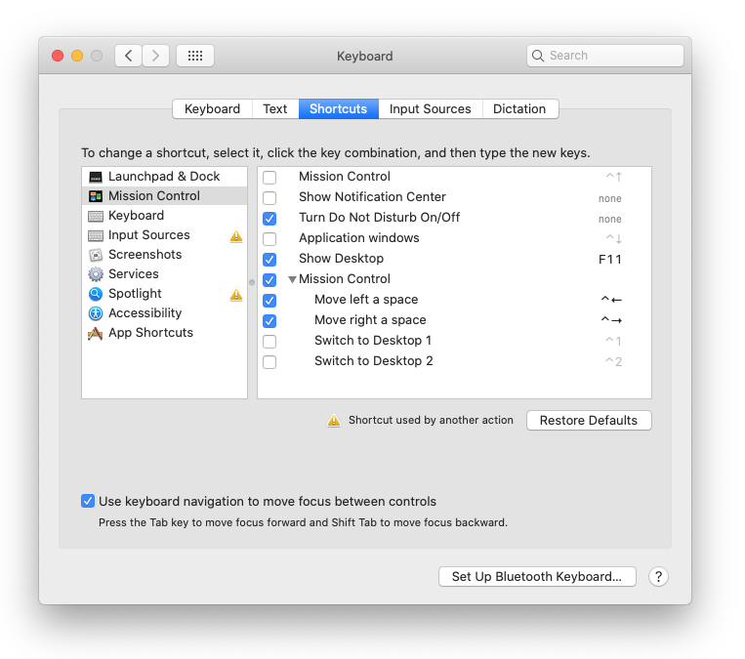

## **Enable Safari Keyboard Accessibility**

Keyboard accessibility must also be enabled separately in Safari too.

Safari Preferences > Advanced > Accessibility > Press Tab to highlight each item on a webpage.

